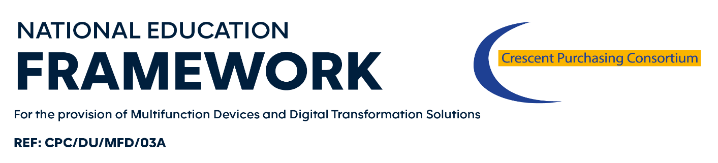
ORDER FORM
(“Statement of Works”)

[_______________] (the End User) wishes to procure the below mentioned Solution from [_______________] (the Supplier), commencing on [________________] and ending on [________________]/continuing for a minimum period of [___________] months (delete as applicable) unless varied in accordance with the Call-Off Contract Terms and Conditions.
The definitions that apply to the Agreement also apply to this Statement of Works.
This Statement of Works is issued under the Call-Off Contract Terms and Conditions (“Agreement”). Customers can use this Statement of Works to specify the Solution requirements they wish to order. The execution and return of this Statement of Works by the End User to the Supplier forms a Contract which is legally binding agreement between the parties. A copy of which (as appropriate) has been provided to the End User and is also available via www.mfdframework.co.uk.
The Agreement applies to the exclusion of all other terms including, without limitation, any terms appearing on a purchase order of which the Supplier seeks to impose or incorporate, or which are implied by trade, customer, practice or course of dealings.
End User Site
Address for Receipt of Solution | Invoice Address (if different)
Post Code | Post Code
Contact Name (PRINT) (Mr/Mrs/Miss/Ms/Dr/Rev):
Tel No: | CPC Membership No:
Email: | Fax No:
Delivery Date: | Installation Date (if different):
Signature (End User)Name and Position (End User) |  | Date:
Signature (Supplier) |  | Date:

Sheet 2 of __
The Solution being purchased is detailed [below/within the attached document entitled [_______________]] (delete as appropriate).
 | Solution |  | Price (ex VAT) | Price (inc VAT)
 | Supplies
 | Software
 | Documentation
 | Services
 | Maintenance
 | Training
 | Manufacturers’ Warranties
 | Reference Standard
Bespoke terms
and conditions
which apply to
this Statement of Works
only
TOTAL PRICE |  |  | £_________________________excl VAT

A completed copy of this form should be emailed to the Help Desk at info@mfdframework.co.uk . Please note this information will be kept confidential and will only be used for internal framework monitoring and management purposes.

CONTRACT No CPC/DU/MFD/03A
Contract for the Provision of Multifunctional Devices and Digital Transformation Solutions

