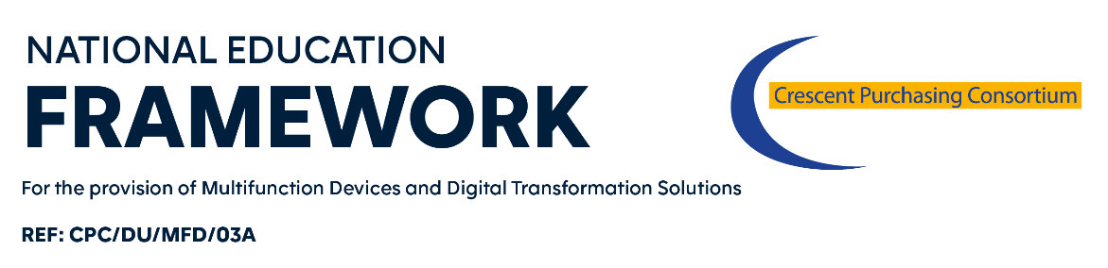
Access Agreement

This is a confirmation of access to the Multifunctional Devices and Digital Transformation Solutions Framework, and an agreement of commitment to use said Framework.
Framework User Contact:  Name:  Email:  Tel: | Supplier Contact:  Name:  Email:  Tel:

Framework Start Date 26th April 2021*
Length of Framework Agreement: 2 years with the option of two twelve month extensions.*

This is an agreement to confirm [enter Framework User name] has satisfied itself of its eligibility to utilise the Framework. Signature of this form constitutes acceptance of the framework agreement Call-Off Contract Terms and Conditions which are enclosed, thereby creating a binding commitment to the utilisation of a Call-Off Contract from the framework agreement referenced above.
We agree to enter into a Call-Off Contract as from [enter date of commence], for a period of [years/months] commencing from the date of signature of this Access Agreement.
The definitions that apply to the Call-Off Contract Terms and Conditions also apply to this Access Agreement. The Call-Off Contract Terms and Conditions apply to the exclusion of all other terms including, without limitation, any terms appearing on a purchase order of which the Supplier seeks to impose or incorporate, or which are implied by trade, customer, practice or course of dealings.
On behalf of the supplier: [enter supplier name]
Contact Name:
Telephone number:
Email Address:
Signature:
Date:

On behalf of [enter Framework User name]
Contact Name:
Telephone number:
Email Address:
Signature:
Date:

A completed copy of this form should be emailed to the Help Desk at info@mfdframework.co.uk . Please note this information will be kept confidential and will only be used for internal framework monitoring and management purposes.

